September 30, 2010 Email: sapetrosky@aol.com

Sylvia A. Petrosky
Attorney at Law
2273 Smith Road
Akron, Ohio 44333
SEARCH REPORT

Dear Sylvia,

In accordance with your instructions of September 23, 2010, we have conducted a status search for Trademark Application No. 4-2007-06057 PURELL. Please find below the details and results for the search.

- General Information

- Search Base:
- Country: Vietnam
- This search has been conducted of (i) National trademark applications filed/national trademark registrations granted by August 31, 2010; and (ii) International trademarks published by May 31, 2010.
- Subject Trademark: PURELL
- Type of Search: Status
- Date of Report: September 30, 2010

- Search Result

The search revealed the following trademark:
Trademark: PURELL
Application No.: 4-2007-06057
Application Date: April 10, 2007
Owner’s Name: Doanh Nghiep Tu Nhan Nam San (VN)
Owner’s Address: 187/9/13 Bach Dang, Ward 2, Tan Binh Dist., Ho Chi Minh City
Class: 3
Status: Lapsed

Best regards,
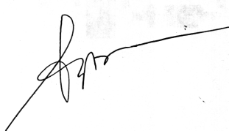
Nguyen Thi Phi Nga, IP Department Head

